Automation Testing: The process in which the expected output is compared with the actual output on the basis of code is called Automation testing.

**Requirement of Automation testing:**

1. To achieve the accuracy within the short interval of time so that we can avoid the human mistakes.

2. Repetition of task is required then we need automation.

3. To improve the testing speed, performance improve.

4. End to end flow test can be done for any number of times then automation is required.

5. Report generation at the completion of testing.

6. Early detection and early resolution process.

7. For parallel testing automation is required.

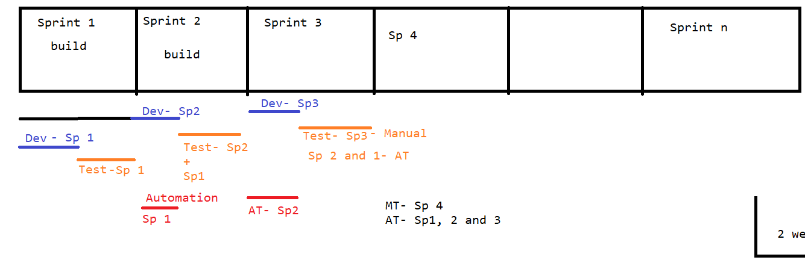

3 factors which we require to have from Automation:

1. Reliable- The code that we have developed should get run at any instant of time.

2. Reusable- One type of code to be used for other similar kind of functionalities to be automated.

3. Repeatable: The code which we have developed it can be used at any number of times.

Java benefits:

Features of java or qualities:

1. Java is platform independent: Write once and run anywhere i.e we can develop the code at one platform but we can execute the same on the same or any other platform.

2. Portable language. In java we can implement a logic which can be used for multiple purposes.

3. Secure language: To secure the data we have a concept called encapsulation in java.

4. Robust language: Java has error handling capabilities which can execute the program even if there is abnormal termination of code condition arrive. Also it has garbage collector which removes the unwanted objects.

5. Multithreaded language: Parallel execution can be done with the help of java.

6. Java is object oriented programming language.

7. Java is very simple language.

**Architecture of java**:

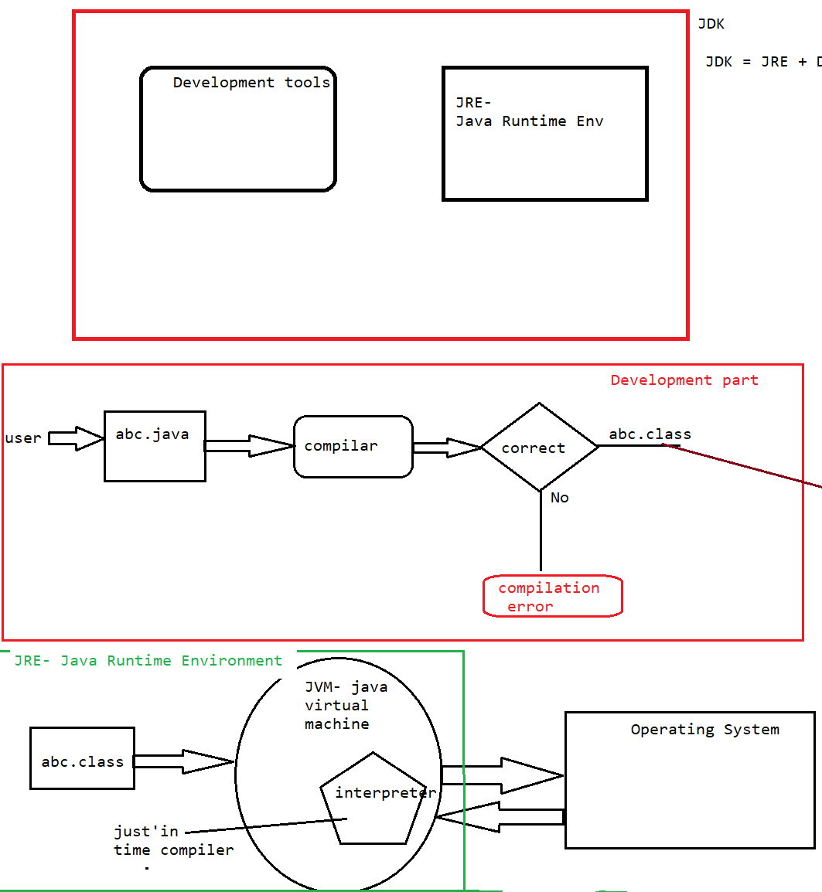

To download eclipse:

<https://www.eclipse.org/downloads/>

**Flavors of Java:**

1. Java-SE (Standard edition) - Core java.

2. Java –EE (Enterprise edition) – Advance Java

3. Java – ME (MicroEdition) – mobiles

The process to build a java program and execution is a 2 step process:

a. Development of a program

b. Execution of a program

a. Development process:

i. **compiler**: It is used to check the program whether it is syntactically correct or not according to java principle. If it is correct then it will convert the program(.java file) into .class file(byte code). But if there is an error occurred during the compilation process then we get an error called compilation error.

ii. JVM: It is an abbreviation for java virtual machine in which the .class file get execute line by line through JVM. It first get the translated code from interpreter then it start the execution of that line and once the execution got done it hand over the output to Operating system then operating system will convey it to the user.

iii. interpreter: It is also known as just in time compiler which is used to translate the .class file’s line and provide it to the JVM for execution purpose.